1.Is it possible to have water vapor at -10°C?

2.A househusband is cooking beef stew for his familyin a pan that is (*a*) uncovered, (*b*) covered with a light lid,and (*c*) covered with a heavy lid. For which case will the
cooking time be the shortest? Why?

3.A perfectly fitting pot and its lid often stick aftercooking, and it becomes very difficult to open the lid whenthe pot cools down. Explain why this happens and whatyou would do to open the lid.

4.What criteria a system should satisfy for it to be in a state of thermodynamic equilibrium and how?

5. Explain the meaning and significance of quasi- static process.

6. State definition of thermodynamic work done .

7. Is there any situation where dV=0 and yet Dw ≠ 0?

8.Drive the work done for open and closed systems and relation between them.

9.State Gibbs phase rule and its importance.

10. What is meant by pure system and state its importance?

11. Why latent heat decreases with increase in pressure ( in T-V diagram )?

12.A cylinder fitted with a frictionless piston contains 5 kg of superheated refrigerant R-134a vapor at 1000 kPa, 140°C. The setup is cooled at constant pressure until the R-134a reaches a quality of 25%. Calculate the work done in the process. Given specific volume at 1000kPa,140ºC is 0.0315 m³/kg and v_{f} =0.000871 also v_{g}=0.020425 .

13.A rigid tank is initially filled with superheated R-134a. Heat is transferred to the tank until thepressure inside rises to a 700 kPa. The mass of the refrigerant and the amount of heat transfer are tobe determined, and the process is to be shown on a P-v diagram.P₁ = 16 kPa,x₁=0.4, v_{f}= 0.0007437,v_{g} =0.12348m³/kg, u_{f}=31.09 ,
u_{fg} =190.27kJ/kg and u = 376.99kj/kg at 700 kPa
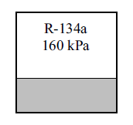

14.A piston/cylinder arrangement shown in Fig. initially contains air at 150 kPa, 400°C. The setup is allowed to cool to the ambient temperature of 20°C.
a. Is the piston resting on the stops in the final state? What is the final pressure in the cylinder?
b. What is the specific work done by the air during this process?

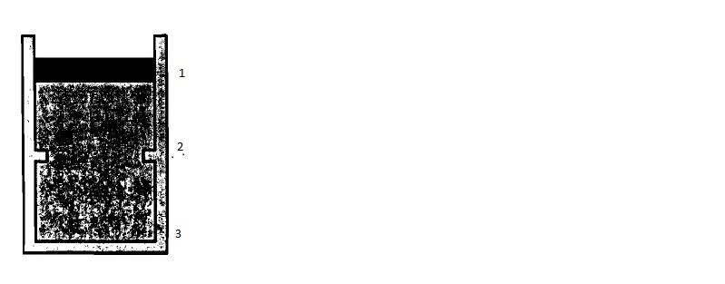

SOLUTION 12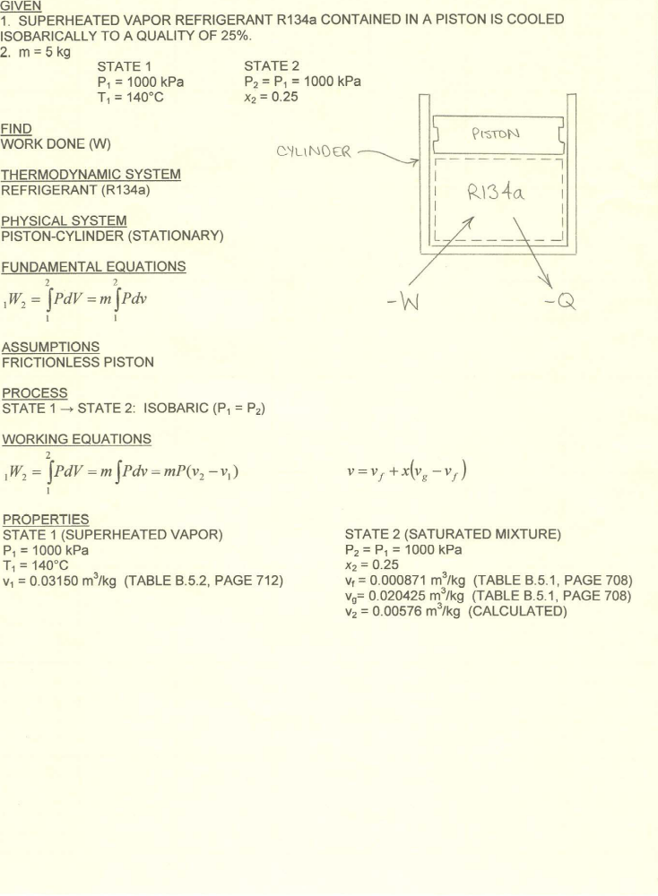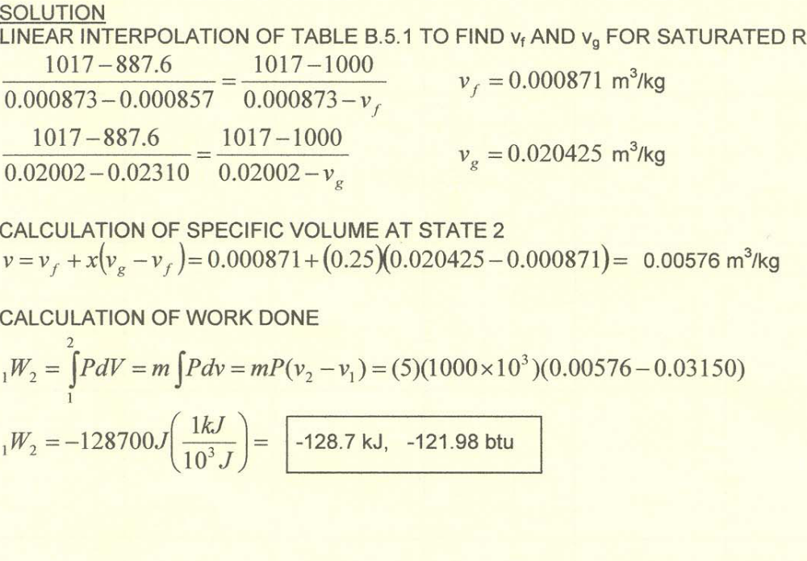

Solution of 13

Assumptions
1 The tank is stationary and thus the kinetic and potential energy changes are zero.
2 Thereare no work interactions.
Analysis
(a) We take the tank as the system. This is a closed system since no mass enters or leaves.Notingthat the volume of the system is constant and thus there is no boundary work, the energy balance for thisstationary closed system can be expressed as
E_{in} – E_{out} =
Q = = m(u₂ – u₁)
(since KE = PE = 0)

Using the date given above

v₁ =v_{f} +x₁* v_{fg}= 0.0007437 +0.4*(0.12348 - 0.0007437) =0.04984 m³/kg

u₁ = u_{f} +x₁*u_{fg}=31.09 +0.4*(190.27) = 107.19 kJ/kg

P₂= 700 kPa, v₂=v₁, and u₂= 376.99kJ/kg superheated condition

Then the mass of the refrigerant is determined to be

m=V₁/v₁ =0.5/0.04984 = 10.03kg

b. Then the heat transfer to the tank becomes

Q_{i n}=m(u₂-u₁) = 10.03*(376.99-107.19)

= 2707 kJ
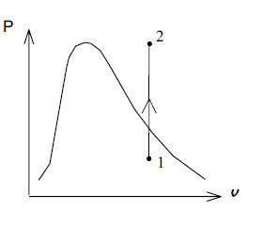

14.A piston/cylinder arrangement shown in Fig. initially contains air at 150 kPa, 400°C. The setup is allowed to cool to the ambient temperature of 20°C.
a. Is the piston resting on the stops in the final state? What is the final pressure in the cylinder?
b. What is the specific work done by the air during this process?

14.Solution: State I: P₁ = 150 kPa, T₁ = 400°C = 673.2 K State 2: T₂ = T_{o} = 20°C = 293.2 K
For all states air behave as an ideal gas.
- If piston at stops at 2, V₂=V₁/2and pressure less than P_{1ift} = P₁
P₂=P₁**= 150*2*=137.2<P₁
So piston is at rest at state 2
- Work done while piston moving at constant P_{ext}=P₁

₁W₂ == P₁(V₂-V₁);
V₂=V₁ = m*R*T₁/P₁
₁w₂=₁W₂/m = R*T₁( = -
= -96.6 kJ/kg

